**Animal welfare practical/master**

------------------------------------------------------------------------------------------------

**Animal control**

There are several methods to control and control animals, and these methods include:-

1- Using some tools and applying physical force: The use of tools and physical force.

2- Psychological Restraint: control or self-control.

3- Inhibition by controlling the senses: Sensory Diminishment.

4- Chemical Restraint: Chemical control.

5- Using Confining Chutes Alleys and Barriers: Using confinement corridors, confinement corridors, and barriers.

These methods are applied to all types of animals.

**Use some tools and apply physical force:-**

**1 – Horse control:-**

Securing of Horse

**1- Lifting the fore limb:** The boss or person in charge of the work stands near the shoulder

The animal is on its left side, facing towards the back of the animal, and it pats its shoulder with its left hand, then He slides it until it reaches the tendon area, then presses the string firmly until the animal raises its leg.

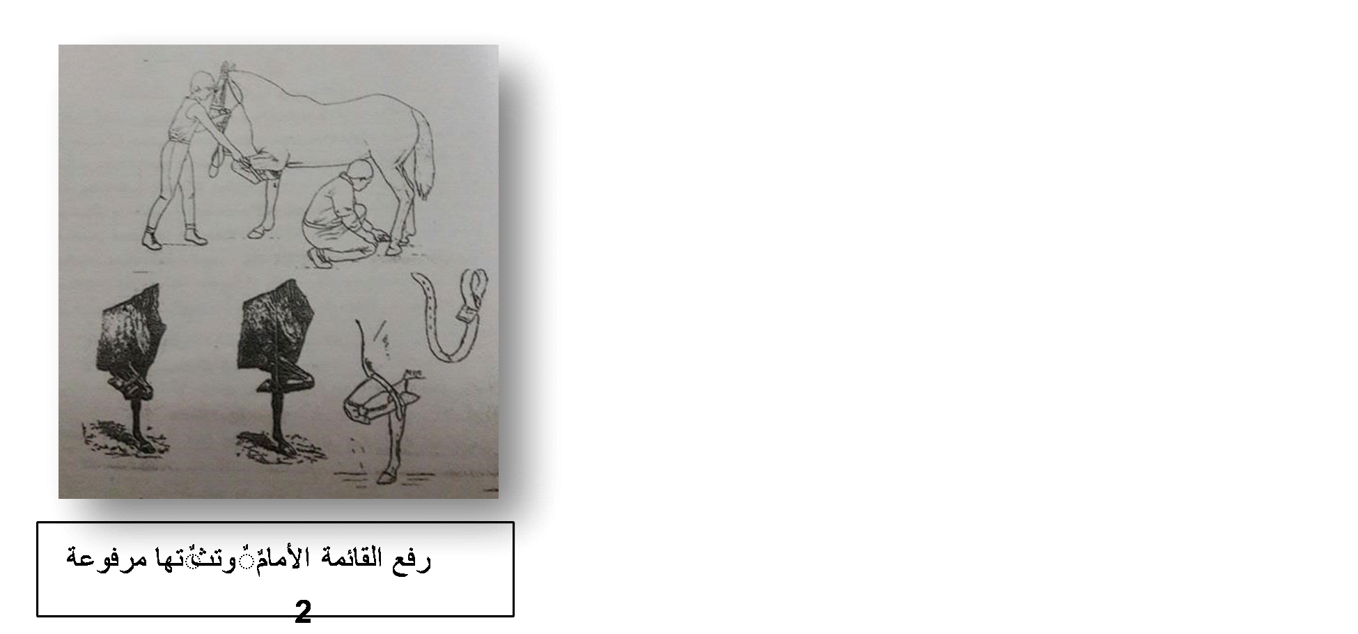

**2- lifting the hind limb:** The groom or the handler stands at his left side, facing towards the back of the animal. The left hand passes over its hind limb until it reaches the middle of the post from the back side, then pulls the handle up and forward towards the animal’s head.

**3: Stocks or Crush -**

It is like a narrow barrier made of iron or wood, inside which the animal is confined and closed at its rear so that it is not allowed to move backwards or forwards. It is the easiest and surest way to control the animal.

**4: Tail method**

The tail is tied with a rope to a specific tie, then the other rope is tied to the restriction area of the back leg.

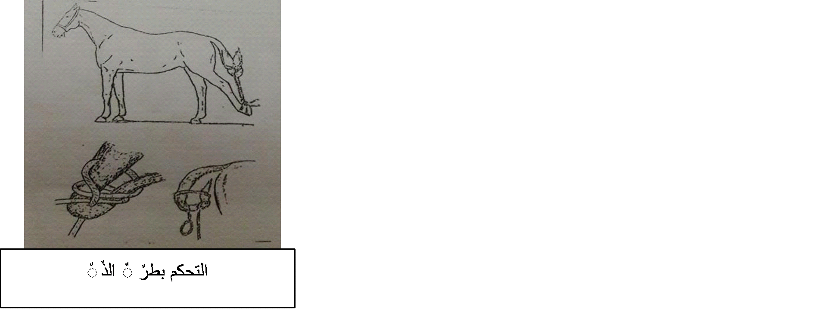

5: Covering Hobbles Twisted service (jumping bars) Al-Hajjar -

This method is used to control both hind legs, and this method depends on linking the two hind legs at the restriction area with two ropes around the neck, so that the hind legs are not allowed to move backwards.

**6: Single side line method**

This method depends on tying one of the hind legs in the restraint area with a rope fastened around the animal's neck.

**7: Twitches -**

These are tools that are applied forcefully to some areas of the animal’s body, such as the ear and upper lip, to cause severe pain in these areas, so the animal turns its attention to the site of the most severe pain, where it is easy to control, and the required examination or other examination is performed with complete ease.

**There are multiple types of twitches:**

* **Traditional twitch:** It can be applied to the upper lip or ear of horses.

* **Wooden Twitch:**

It is applied to the upper lip only and has different models.

* Metal Twitch streams:

It is applied to the upper lip only.

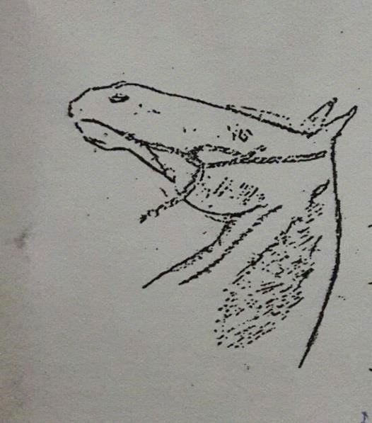

* **Loop Twitch:**

It is applied to the lower jaw

* : Galvaynes Twitch for Galvaynes streamer

**8 - The side stick method**: It is used to bend the animal’s head and neck forward to prevent it from biting or licking the ointments applied to the affected area or biting the wounds that it may inflict.

**9 - The wooden collar method**: It is similar to that of horses and is used for the same purposes in the previous method.

**10 - The method of holding the ear**: A good method used to control the animal while standing, and it requires firmness and strength.

**11 - Gypsy hold method**: It includes holding a fold of skin with a thin muscle layer on the back of the neck, holding it firmly while holding the head.

**2- Controlling cows**

**Securing of cattle**

There are several methods in which physical force is applied to control cows, the most important of which are:

* : Seizing the septum nasi holding the head with the nasal septum

The assistant held the cow's head with the nasal septum, pressing it with his thumb and index fingers.

* Nose holder forceps: used to lead or control the animal while standing, and there are different models.
* 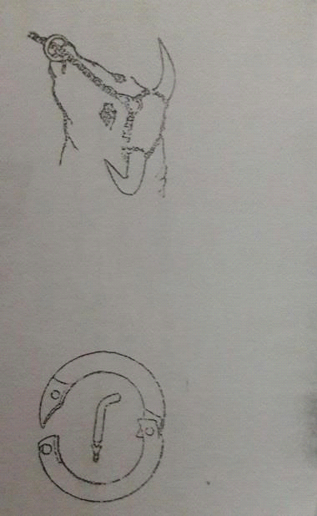Nose ring: It is placed in the nasal septum and permanently attached to control the animal. It is of two types:
* Self-piercing bull ring: This is a ring with a sharp tip used to pierce the nasal septum.

Ordinary bull ring: Ordinary bull ring

When installed, a nose piercing is used to pierce the nasal septum, and the piercing is 1-2 cm away from the front of the nose.

: Stanchion heretic

It is similar to what is used to control horses to prevent kicking.

**: lifting the fore limb**

: lifting the hind limb

**The wooden collar method**: It is used to prevent the cow from goring or breastfeeding itself, or to prevent it from reaching the touch of ointments applied to the areas within its reach.

**Controlling the hind legs in cows:**

The most important of these methods are:

1. **Cow strap or hock strap**: This method is applied by tying a rope in the shape of a number / 8 / over the hocks and restricts the animal so that it is not allowed to move the hind legs. This method is also used during the examination of the udder or for any light surgical intervention on the list. When the animal is standing, or when it is accustomed to kicking during milking.

**2. The tail method**: where the tail is passed between the two hind legs and wrapped around the top of the hock, and a strong assistant holds it tightly so that the cow is unable to kick.

**3. Fixing the hock area**: A rope is tied above the right button (the milkmaid’s side), then the end of the rope is pulled back by someone like a helper or tied to a stake in the ground.

**4. Tie behind the udder**: Udder cinch: A rope is wrapped around the animal’s body near the flank, so that it passes behind the udder and is then controlled from the side of the animal’s back. A helping person pulls the other end of the rope back.

5. Holding the groins area: Hold the groins area firmly with your hand to prevent the cow from kicking.

  Hobbes cow:

7. **Leg twtiche method**: This is a method applied to examine the hooves of the back leg, and it relies mainly on pressing the tendons of the leg and the leg rises.

**3 - Controlling sheep**

Securing of sheep

A: Portable sheep stock

It includes a piece of strong wood in the shape of the letter Y, with its lower end pointed to be fixed in the ground like a stake, and the sheep’s head is fixed between the two upper branches with an iron or wood rod passed through a hole in both branches.

B: Brentifield table B – Brentifield table

The table is characterized by the presence of a depression or concave on its surface where the body of the sheep can be placed within it, and it is equipped with a cover on one side that is fixed at one end and moved at the other end in the form of a semicircle so that it can be closed to press the body of the animal and then fixed on the other side of the table.

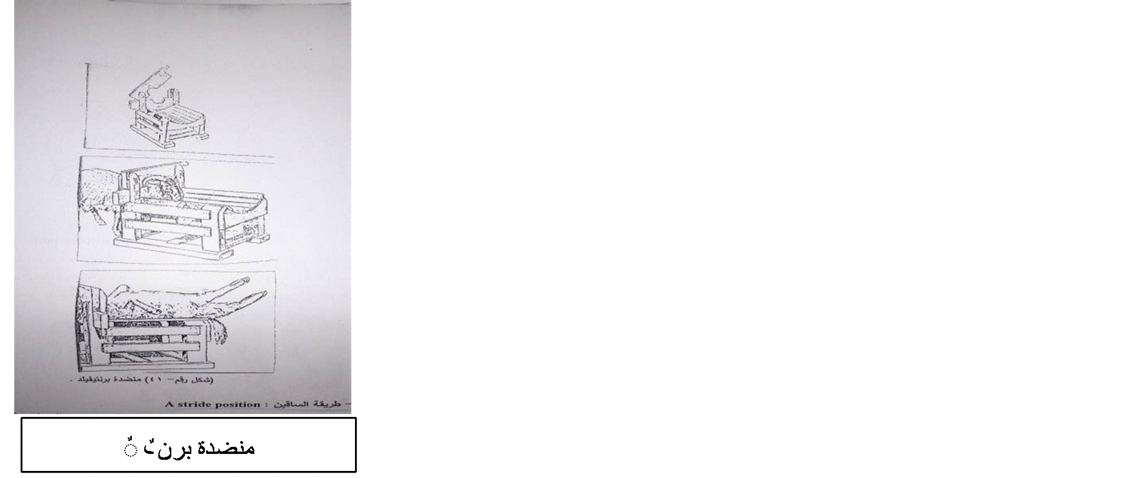

C - A Stride position method: In this method, the assistant stands with his legs spread apart to pass the animal between them, then tightens his legs on the animal’s body, then holds the horns or ears with his hand well.